Airmaster E-Commerce Platform - Design Document
This document outlines the architecture, database schemas, and scalability strategies for the Airmaster E-Commerce Platform, designed to handle 10M+ daily orders and 100K+ concurrent users safely and efficiently.
1. System Architecture Diagram
The system employs a decentralized Microservices Architecture, using an API Gateway to handle ingress traffic and an asynchronous Event Bus (RabbitMQ) for inter-service communication to guarantee eventual consistency and fault tolerance.
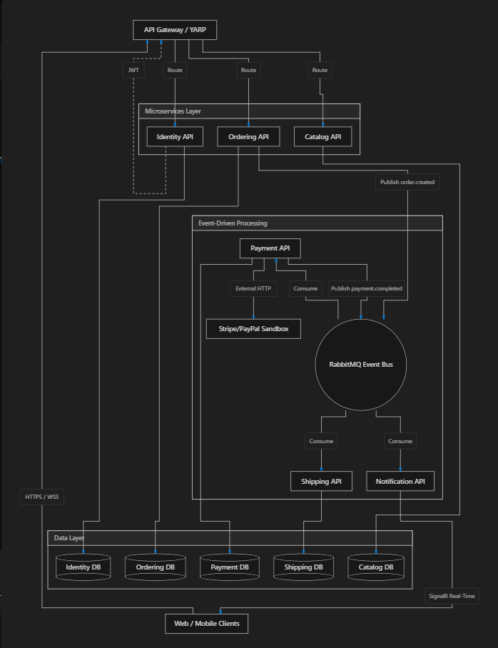
2. Database Schema (Database-per-Service Pattern)
To ensure loose coupling, each microservice owns its data store. We are using Microsoft SQL Server (LocalDB for development) managed via Entity Framework Core Code-First Migrations.
Catalog Database (Airmaster_CatalogDb)
- Product: Id (GUID), Name (String), Description (String), Price (Decimal), StockQuantity (Int), CategoryId (FK)
- Category: Id (GUID), Name (String)
Ordering Database (Airmaster_OrderingDb)
- Order: Id (GUID), UserId (GUID), OrderDateUtc (DateTime), Status (Enum: Pending, Paid, Shipped), TotalAmount (Decimal)
- OrderItem: Id (GUID), OrderId (FK), ProductId (GUID), UnitPrice (Decimal), Quantity (Int)
Payment Database (Airmaster_PaymentDb)
- PaymentTransaction: Id (GUID), OrderId (GUID), UserId (GUID), Amount (Decimal), TransactionStatus (String), GatewayReference (String, e.g., Stripe TXN ID), ProcessedAtUtc (DateTime)
Shipping Database (Airmaster_ShippingDb)
- Shipment: Id (GUID), OrderId (GUID), Carrier (String, e.g., FedEx/UPS), TrackingNumber (String), DispatchedAtUtc (DateTime)
Identity Database (Airmaster_IdentityDb)
- User: Id (GUID), Email (String), PasswordHash (String), FirstName (String), LastName (String), Role (String)

3. Microservice Boundaries
The domain is split by bounded contexts to prevent bottlenecks:
- Gateway (YARP): The single entry point for all clients. Handles CORS, IP-based Rate Limiting, and reverse proxy routing.
- Identity.API: Handles authentication, token generation (JWT), and user profile management.
- Catalog.API: A read-heavy service serving the product catalog and stock levels.
- Ordering.API: Manages the shopping cart checkout process and order lifecycle state.
- Payment.API: An asynchronous background worker that integrates with external payment gateways using resilient HTTP clients (Polly).
- Shipping.API: Assigns carrier details and tracking numbers once payments are cleared.
- Notification.API: Manages persistent WebSocket/SignalR connections to push real-time order status updates back to the active user's device.

4. Scaling Strategy
To achieve <1s latency and handle spikes (e.g., Black Friday):
- Asynchronous Message Queues: By utilizing RabbitMQ, the Ordering API can accept the HTTP request and immediately return a 202 Accepted to the user. The heavy lifting (Payment -> Shipping) happens entirely in the background, keeping the HTTP threads unblocked.
- Dead-Letter Queues (DLQ): Failed messages in RabbitMQ (e.g., if the Payment API crashes) are routed to a Dead-Letter Exchange (AirmasterCentralExchange.DLX) for manual inspection and replay, ensuring zero dropped orders.
- Future Cloud Deployment (Azure):
  - Migrate SQL LocalDB to Azure SQL Database Serverless for auto-scaling compute.
  - Deploy microservices to Azure Container Apps, configured to auto-scale out based on RabbitMQ queue depth (KEDA integration).
- Future Caching (Redis): To achieve sub-millisecond latency on the read-heavy Catalog API, a distributed Redis cache should be placed in front of the Catalog SQL database.

5. Security Considerations
The platform implements multiple layers of security, particularly aimed at protecting PCI-DSS sensitive pathways and preventing volumetric attacks.
- Authentication & Authorization: Implemented via JSON Web Tokens (JWT) using SymmetricSecurityKey with HMAC-SHA256 signatures. Tokens have a short lifespan (15 minutes) to reduce the attack surface of stolen sessions.
- Rate Limiting: The Gateway implements Microsoft.AspNetCore.RateLimiting to defend against DDoS attacks:
  - Token Bucket Limiter: 20 tokens per IP for standard read-heavy endpoints.
  - Fixed Window Limiter: 100 requests per minute for strict security pathways.
- Circuit Breakers (Polly): The Payment service uses .AddStandardResilienceHandler() to wrap calls to Stripe/PayPal. If the third-party gateway experiences an outage, the circuit opens, preventing our internal services from exhausting their connection pools.
- SQL Injection Prevention: All databases interact strictly through Entity Framework Core, which automatically parameterizes SQL queries.

